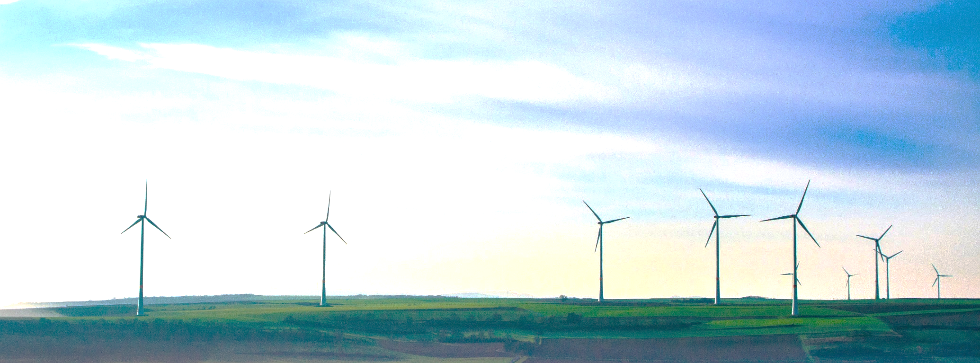
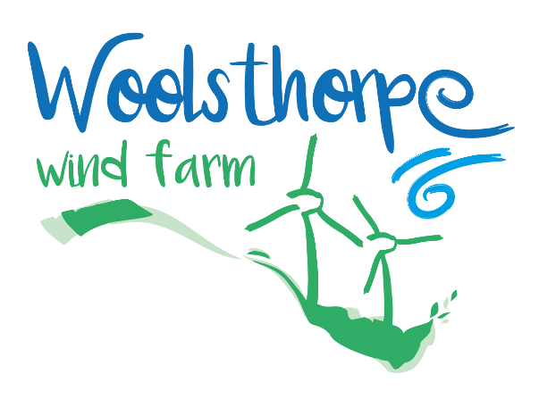

Schedule 1 – Application Form
WWF Preconstruction Community Fund Program Application Form Overview
Woolsthorpe Wind Farm (WWF) is pleased to offer financial support to the local Woolsthorpe community by extending its Community Benefit Fund grant program to the current Pre-construction stage of the Project. The grant program during this pre-construction stage will provide a once off allotment of funds of $15,000 to $20,000 to community causes.
WWF has decided to offer this pre-construction funding following discussion with community member representatives on the Community Engagement Committee, recent progress made advancing the Project’s grid connection offer workstream, and as a thank you to the community for their patience with us and the Project.
Organisations with suitable local community initiatives are encouraged to apply by filling out an application form on the next page.
Before submitting, to confirm your initiative, cause and or project is eligible, please consult the Pre-construction Community Benefit Fund Details document, including both the Applicant Eligibility Criteria and the Grant Eligibility Criteria.
Applications close: on Friday 30 September 2022.
Submission: Forms can be submitted directly by email to contactus.woolsthorpe@elecnor.com. The goal is to provide financial support for projects that contribute to the social, economic, educational and environmental sustainability of the community in the vicinity of the WWF.

Pre-construction Grant Application Form
Application Details
Project Name
Project Location
Maximum amount applied for (AUD$)
Expected date of project completion
Individual or Organization Applying to the Fund Grant
Name
ABN (if applicable)
Brief description (in case of being an Organisation)
Contact Details / Organization Representative
Name
Phone
Email
Project Details
Include in this section information about the project and how it will help to contribute to achieving the goals of the Community Fund Program. Reference to the “WWF Community Fund Program Guidelines” is important.

A summary of what the project is, including location
An indication of the objectives of the project, what the planned outcomes are and how they can be measured
An explanation of how the community will benefit
Who will manage the project
What the overall cost of the project is
What the timeline of the project is
Any other relevant and important details
Declarations and Information
How did you hear about the Community Fund Program?
Are there any disclosures regarding the project or your organisation you wish to make?
Are you, or is your organisation willing to allow the project to be used for promotional purposes by WWF?
Applications can be submitted via email to contactus.woolsthorpe@elecnor.com.

Schedule 2 - Terms and Conditions
The following terms and conditions apply to all applications:
- WWF reserves the right to control funding amounts and payment types.
- WWF is not required to provide reasons for grant refusal or partial funding.
- WWF reserves the right to withdraw funding if a grant is not used for the project outlined in the grant application.
- If the purpose of the initiative and or project is no longer appropriate or cannot be completed in the time frame stipulated in the funding agreement, the recipient must advise WWF.
- All unspent money from a grant is to be returned to WWF for it’s proper use in other applicant’s projects.
- The Applicants initiative and/or project must be complete prior the grant application process closing for the following year.
- The applicant will maintain appropriate insurance.
- The risk and responsibility for any initiative and or project funded by the grant rests exclusively with the Applicant and this statement intends to exclude any and all liability claims against WWF.
- If requested to do so, Applicants must provide acknowledgment of funding such as displaying the WWF logo or statements in writing that WWF has provided funding.
- Any acknowledgments and/or publications or the like must be provided to, and approved by, WWF prior to being used in relation to any grant assisted project.
- Projects receiving grants under this program may be publicised by WWF.
- The terms and conditions of a funding agreement are to be read and signed by the Applicant before any funds are distributed.

